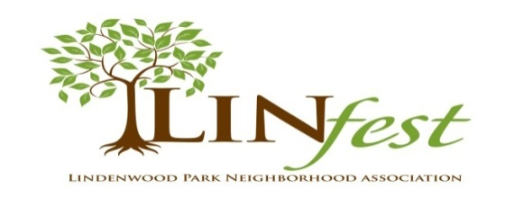

Lindenwood Park Neighborhood Association
P.O. Box 39036
St. Louis, MO 63139
Email: linfest@lindenwoodpark.org

Dear Lindenwood Park Neighborhood Business Owner:

We are thrilled to announce the date for LinFest 2020, our neighborhood Fall Festival! Due to the outstanding success of LinFest in 2018 we are anticipating another great response from local vendors and sponsors.

LinFest is sponsored by the Lindenwood Park Neighborhood Association (LPNA) and will be held on:

Saturday, October 3, 2020 from 11am – 4pm

LinFest will take place at the North end of Lindenwood Park at Jamieson and Pernod. LinFest will introduce and reacquaint visitors to the many businesses and restaurants in our neighborhood, help vendors promote their business and grow their customer base for future success. There will be performances by local schools, a band and entertainment/arts and crafts for the children; food, drinks and many more events planned. Lindenwood Park has some of the best restaurants in the City of St. Louis and we are proud to have them participate in LinFest.

Announcements will be posted via various social and print media - including Twitter, Nextdoor Facebook, our website (www.lindenwoodpark.org), various periodicals and on a billboard at corner of Watson and Chippewa. The aldermen of our neighboring wards, along with nearby neighborhoods, schools, churches and organizations will be asked to promote LinFest. Block captains and businesses will distribute fliers and we will ask businesses to display posters.

This is a great opportunity to spotlight local businesses, increase community awareness, and celebrate our Lindenwood Park neighborhood. As you know, LPNA does everything we can to promote local businesses and support the neighborhood and this is our major event of the year.

Please consider being part of LinFest as a sponsor or a vendor (or both) as this is a great way to promote and market YOUR business and generate neighborhood support. Enclosed please find a Vendor and Sponsor Agreement, a Liability Release and an Application Form to be completed if you are interested in participating as a vendor or sponsor at LinFest.

For more information, please contact us at linfest@lindenwoodpark.org.

Sincerely,

MaryAnn Rogers and Emily Rogier
LinFest Co-Chairs
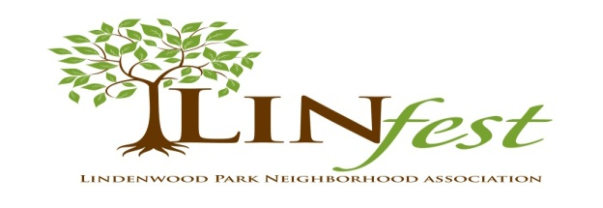
Saturday, October 3, 2020 – 11am – 4pm, at Jamieson and Pernod

VENDOR AGREEMENT

Participating LinFest businesses and restaurants will receive:
- 10’x10’ booth space;
- 1 Tent (if needed – vendors may provide their own branded tent – please advise us if you’ll use your own);
- 1 Table and 2 chairs (you may bring extra but they may not encroach into neighboring vendor space);
- Signage/branding rights at booth location (self-provided).

The Participants agree to the following:
- Will cooperate in obtaining the necessary Health Department permit, if required. (LPNA will obtain the Health Certificate for food vendors – this is included in the Vendor fee). The Health Certificate, once applied for, will be provided to LPNA several days before the event. Vendors will receive the Health Certificate from event organizers on event day.
- Will furnish LPNA a Certificate of Insurance naming LPNA as “additional insured” as required by the City of St. Louis. Minimum limit $1,000,000 (please call your insurance agent to obtain).
- Will obtain the necessary inspection and permission of the St. Louis City Fire Department if any open flame cooking and/or the use of pressurized gas (propane) will be used.
- Will not reassign the use of any vendor space without the prior approval of LPNA.
- Will be responsible for collecting, reporting and paying all Federal, State and St. Louis City taxes.
- VENDOR is responsible for obtaining the required City and State licenses for alcohol sales if providing any alcohol at LinFest and must show organizers proof of license, which is available from Liquor Control at City Hall, at least 30 days before event date. All staff shall be properly trained to ID customers and handle the sale of alcohol.
- Will not serve menu items in glass containers.
- Will be responsible for the security of their booth area, goods and personal items.
- LinFest has the right to photograph all vendor booths and exhibits for publicity purposes.
- Set up and Take Down: Vendors may begin Set Up at 9am. Please use hand-carts to carry additional products to your booth between 11am and 4pm. Vehicles will be permitted on the festival grounds for Take Down beginning at 4pm. All vehicles must be removed from the festival grounds area by 7pm.
- Will abide by any additional requirements.

Vendor Liability Release

The undersigned agrees and does hereby release from liability and to indemnify and hold harmless LPNA, and any of its board members, committee members, employees (if any) and volunteers from any personal injuries and property loss or damage in connection with any LinFest activity. This agreement for LinFest is between the vendor and the Lindenwood Park Neighborhood Association.

Vendor: _____________________________________________________________________________________

Signature: _____________________________________________ Date: ______________________________________

Please Print Name: __________________________________________________________________________________
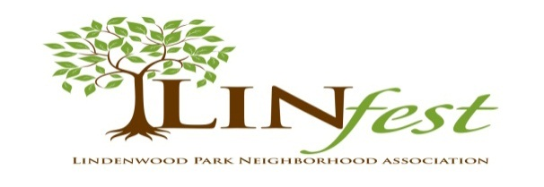
Saturday, October 3, 2020 – 11am – 4pm, at Jamieson and Pernod

Vendor Application

Contact Person: ____________________________________________________________________________________

Business Name (to appear in promotional material): ____________________________________________________________

Email: _______________________________________ Federal Tax ID #: ______________________________________

Website Address: ______________________________________

501(c)3 #: ___________________________________
(To be posted in announcements) (For non-profit organizations only)

Street Address: ___________________________________________________________
Zip: _____________________

Phone #: _____________________________
Cell Phone (for event-day contact): __________________________________

Electricity is available to vendors free of charge. Please remember this is an outdoor venue and power capabilities will be limited. Electrical service will provide 10 amps at 120 volts single-phase (normal household electric service). Your equipment must have properly grounded lines, etc. Please furnish your own extension cables.
If you will need electrical service, please check the box: □

Please provide information about the products or food samples that will be available at your booth, price range and any information that would be helpful when advertising LinFest.

Participation Fees for Vendors:

$85 – business /artisan vendors • $185 - food only vendors (tent or truck) • $280 – food and/or alcohol vendors (tent or truck)
This registration fee covers the City of St. Louis permits and expenses for the event.

Please submit the Application and Liability Release forms by September 1, 2020, together with a copy of your Insurance Certificate (agent may email it to linfest@lindenwoodpark.org), the completed City Health Permit (if serving food) and your check made payable to:

Lindenwood Park Neighborhood Association
P O Box 39036
St. Louis, MO 63139

Once you are confirmed as a participant and your check is deposited, NO REFUNDS WILL BE ISSUED.

Vendor: __________________________________________________________________________________________

Signature: ________________________________________________________________________________________

Please Print Name: _________________________________________________________________________________
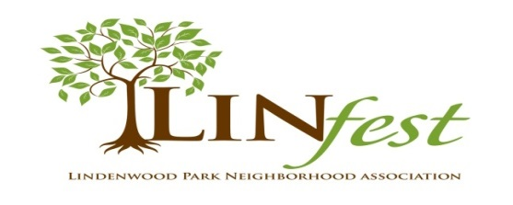
Sponsorship

There are several levels of sponsorship available. If you would like to support LinFest as a sponsor, thereby receiving banners, mentions, and free booth, please complete the additional form below and submit with your Vendor Application and Vendor Agreement forms.

Please consider being a sponsor at LinFest. As a sponsor you will receive:

$1000 | LinFest Sponsor | - Your company logo and name displayed on a banner situated on the main stage.  - Your company logo and name will appear on billboard at Watson & Chippewa (over 145,000 impressions) and all promotional materials  - No cost for a booth/tent
$500 | Banner Sponsor | - Your company logo and name displayed on a banner at the entrance to LinFest.  - Your company logo and name mentioned on all promotional materials.  - No cost for a booth/tent
$300 | Event Sponsor | - Your company logo and name mentioned on all promotional materials.  - No cost for a booth/tent
$200 | Activity Sponsor | - Your company name and logo on a sign at the activity.

Please check the sponsorship you would like to purchase:

□ $1,000 (LinFest Sponsor) □ $500 (Banner Sponsor)
□ $300 (Event Sponsor) □ $200 (Activity Sponsor)

Contact Person: ____________________________________________________________________________________

Business Name (to appear on promotional material): ___________________________________________________________

Email: _______________________________________ Federal Tax ID #: ______________________________________

Website Address (to be posted in announcements): ___________________________________________________________

Facebook and/or Twitter address: _____________________________________________________________________

Street Address: ___________________________________________________________ Zip: ____________________

Phone #: _____________________________ Cell Phone (for event-day contact): __________________________________

SPONSORS PLEASE EMAIL YOUR COMPANY LOGO IN .JPG FORMAT TO linfest@lindenwoodpark.org

