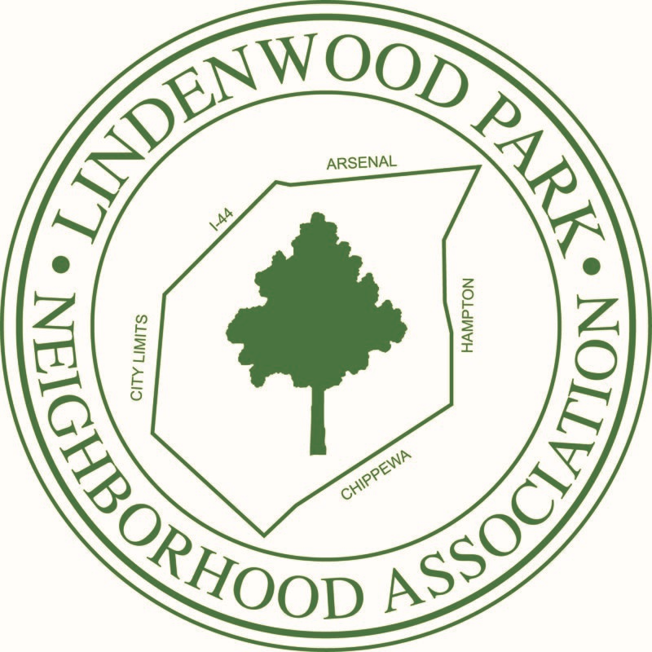

Below are some tips and resources to help you organize your block.

**About Block Units**

A block unit is about neighbors knowing each other, people watching out for each other. It is people coming together to clean alleys, plant trees and flowers, or work with City government to meet area needs. It is where we live, raise our families, work, and play. What happens on one block affects the street, which affects the neighborhood, which in turn affects the whole of St. Louis. The stronger our blocks, the stronger our City. Block Units create the foundation for a stronger, safer, and more vital neighborhood. They are the building blocks of a neighborhood organization.

**Organizing your block**

**Know Your Resources:**

* **Citizens Service Bureau** – 314-622-4800: Customer service department for City government; place to register complaints about City services
* **Neighborhood Improvement Specialist** – Karen Clifford - Cliffordk@stlouis-mo.gov or office phone is (314)657-1354. Karen is our direct contact for problem properties and complaints.
* **Alderman – Joe Vaccaro**

**Setting a Time and Place for a Block Party or event:**

Make your meetings or social gatherings at times that are convenient for most of the people on the block. See attached document on successful block parties.

**Keeping everyone informed:**  
Flyers let everyone on the block know about the event. State time, location, and reason. Recruit neighbors to help distribute them door-to-door. If you have a library card you can make 50 copies per month at no cost. See attached templates to help organize your block , communicate about meetings, issues, concerns and announce events.

**Remember, by getting organized, you and your neighbors will have a unified, powerful voice that will be heard and will be more effective than individuals working on their own.**