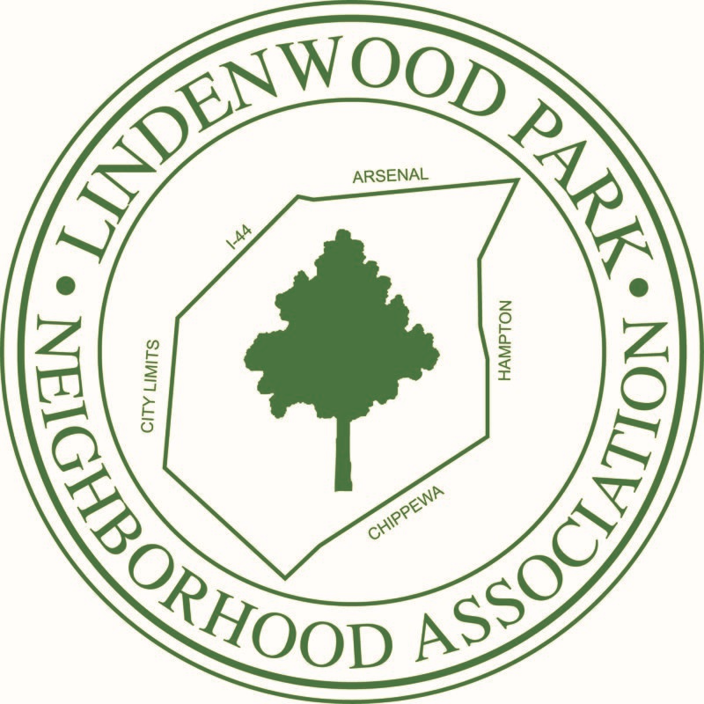

Hello and welcome to the ____ block of _____! We’re glad you’re here. I live at ____ and have been here for ____ years.
I am a block captain for this block, which means I am the point person for concerns and issues and your liaison to the Lindenwood Park Neighborhood Association(LPNA) and city resources.
If you ever have a question about living here, whether it’s where’s the nearest library, where to report a burned out streetlight, or how to report a problem property, please don’t hesitate to reach out.
You can connect to neighbors via the website, social media, and the private social platform NextDoor.com, and you can visit the LPNA website at www.lindenwoodpark.org to learn more about our community, the LPNA, events and neighborhood meetings. .

